Problem 04

Goal:

We decide to implement a method to identify a "puddle" on the ground and reduce the speed to cross it (move around it?).

Method:

The key part of this implementation is to identify the puddles on the ground. Different from the method used to recognize the stop sign and foods, we cannot use CNN to identify the puddles. The reason is that the puddles are on the ground which makes it hard to catch the clear picture by camera. Moreover, we do not have a training model for the puddles. Therefore, we decide to use the Lidar to identify the puddles.

Due to its special material, the puddles have a reflective surface which will create a high intensity reflected the beam to the lidar. Thus, we can apply a filter to the raw data from lidar to identify the puddles. Basically, there are two steps to achieve the goal.

1. Apply the filter to abstract the point could of puddles

First, we add a filter (intensity filter) to remove the points which have a lower intensity of reflection. Since the puddles are not the only staffs that have high intensity reflected the beam to the lidar (walls, fence also have a high reflection rate). We add another filter (height filter) to remove the points whose elevation (z-value) is relatively large. After applying the two filters, there are only several hundred points left.

1. Identify the points of the wall

Although we remove most of the unused points in from the raw data, the point could for walls still satisfy the above two filters. Therefore, we need to find classify the points.

Because there are only two types of points left now (walls and puddles). We can use the location of walls from gmapping to identify the points for walls.

1. Identify the puddles

After classifying the points of walls and puddles, we can confirm the points belong to puddles. Finding the center of data with an additional radius, we can locate the puddles on the map.

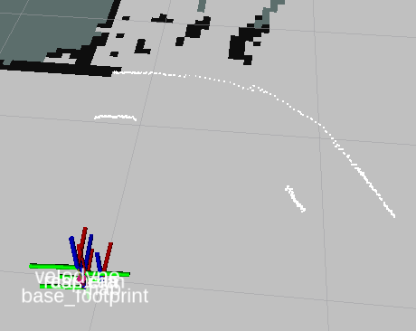

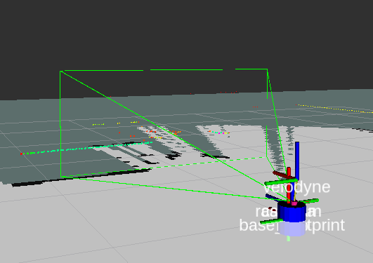

(filtered point could we get with walls)

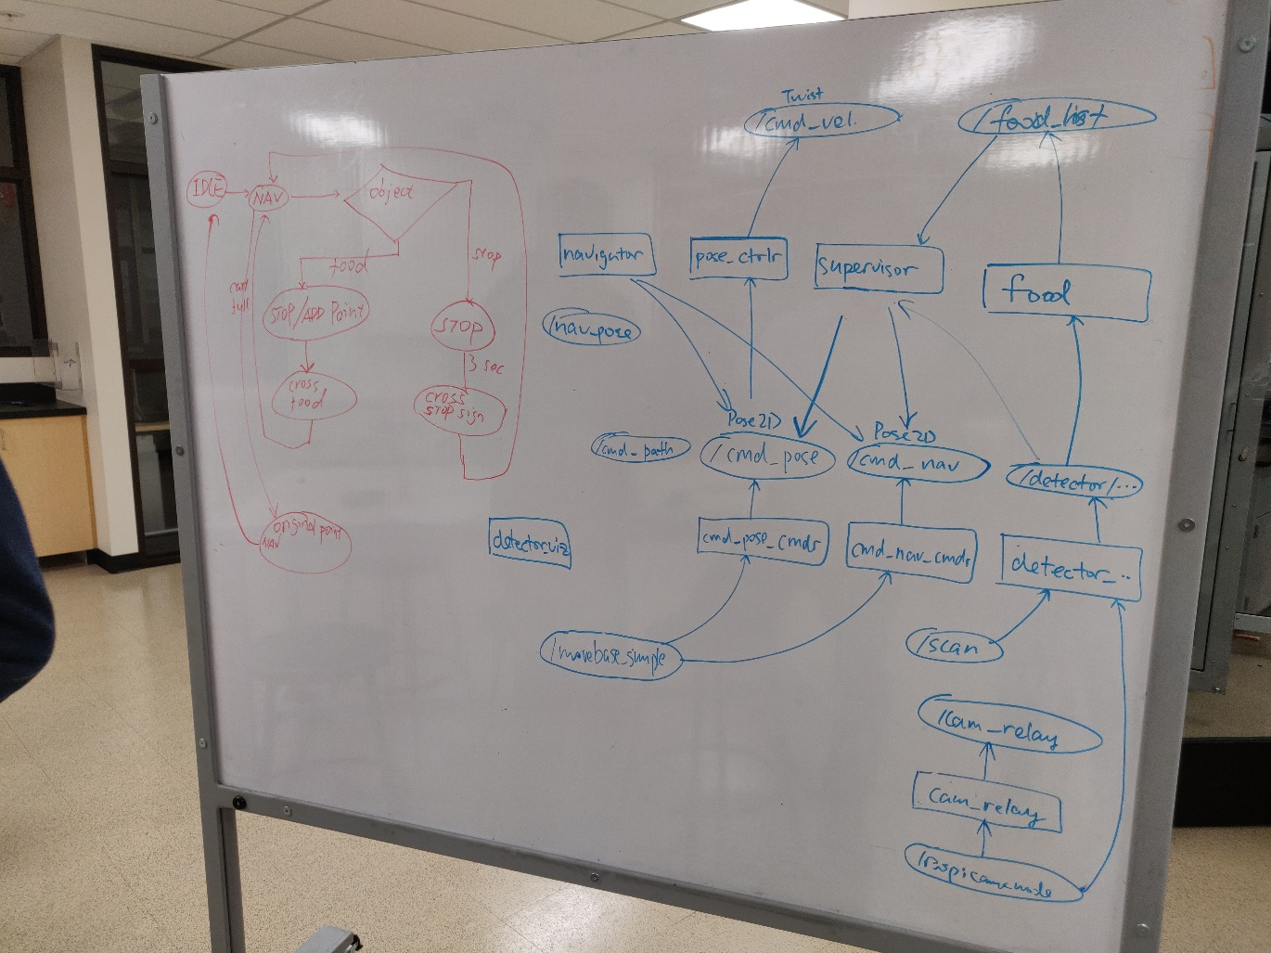

(Nodes & Topics & FSM)